In this statement we will learn the basics, some processes of steganography in case of using pictures.

Understand the functional part of this steganography process python codes will be given end of the discussion.

To understand the steganography process first let us understand some topics of steganography and related to it.

**What is steganography?**

Steganography is mainly a technique of hiding a secret data. This secret data can be in format of text, picture, audio and video. This secret data will hide within image or audio file and this file will called as cover image. Steganography is used for mainly for avoid detection of secret data, in summary for data protection.

This steganography word came from New Latin Steganographia. Which is a combination of two Greek words steganós meaning "covered or concealed" and graphia meaning "writing".

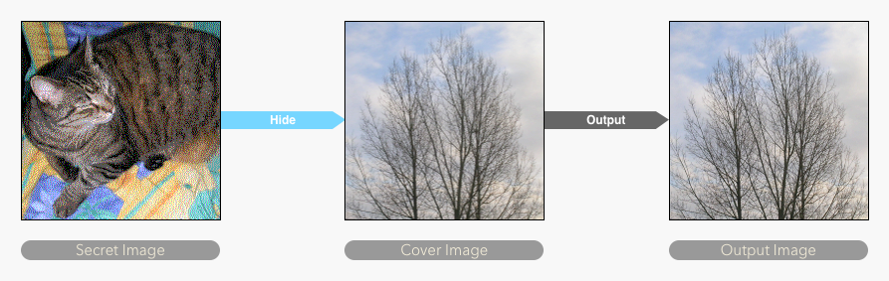

**Steganography in History**

The idea of steganography was not invented in the modern era. This technique is being practiced from ancient time. The first use of this term was first recorded in 440 BC by Herodotus. Herodotus used steganography in his “Histories” book describing two examples. Also, Steganography technique was widely used in wars at the ancient time.

Some story of steganography used in ancient time and so on years are discussed below:

1. The Greek ruler Histaeus first shaves the head of a slave, then writes the message in the head and waits for the growth of hair to disclose the secret message. At last he sends the slave on his way to deliver the message. The recipient shaves the head of the messenger to uncover the message. The recipient would reply in the same form of steganography.
2. During the American Revolutionary War both the British and American forces used various forms of Invisible Inks. Invisible Ink was made from common sources, this included milk, vinegar, fruit juice, and urine, for the hidden text. To see these hidden messages required light or heat.
3. During World War II the Germans introduced microdots. Mainly Germans and French used this process to send secret messages. These microdots were complete documents, pictures. Microdots are mainly text or images reduced to a very small size (about 1 mm in diameter)

**Advantages of steganography**

First advantage of steganography must be compared with cryptography because this cryptography defined as also a process of securing data. But comparison between these two processes. steganography will come up as winner. Cryptography doesn’t hide the secret message it only converts the message but the steganography technique hides the message or file in a way that it can not be suspicious to anyone. Also, during sending this secret information steganography is most discreet than cryptography and the extraction process is easy in steganography.

**Steganography > Cryptography**

Before starting the important topics related to steganography process for picture to picture, we need to know some information about Digital image, pixels and color models.

**Digital Image and Pixels**

Digital image is basically an image and it contains finite set of digital values, called pixels. In a digital image these pixels are just a smallest individual element. These pixels hold the value which is responsible for the brightness in a specific point of an image. The concept image is mainly a representation of a matrix or a two-dimensional array of pixels which contains a fixed number of rows and columns.

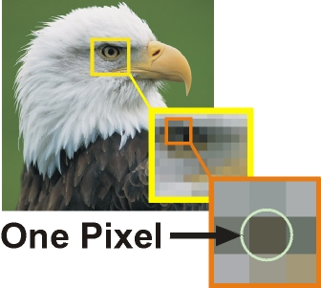

**Color Models**

In images or color imaging systems, a color is represented by combining three or four colors, such as red, green, and blue, or cyan, magenta, yellow, and black.

Here we will work with Red, Green and blue so we will be discussing about Red, Green and blue color model or RGB color model.

**RGB color model and LSB method**

From the name we can easily see this color model is all about red, green and blue color. But for information we can define RGB color model – “The RGB color model is an additive color model in which red, green and blue light are added together in various ways to reproduce a broad array of colors.” The idea of RGB color model is used mainly in purpose of sensing, representing, and displaying images in electrical systems like- television, computer monitor etc.

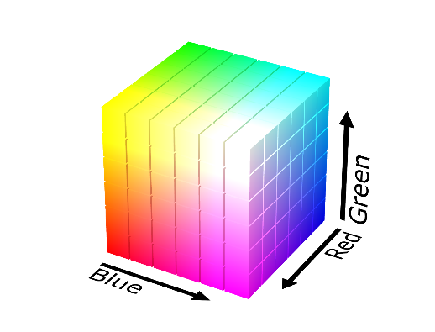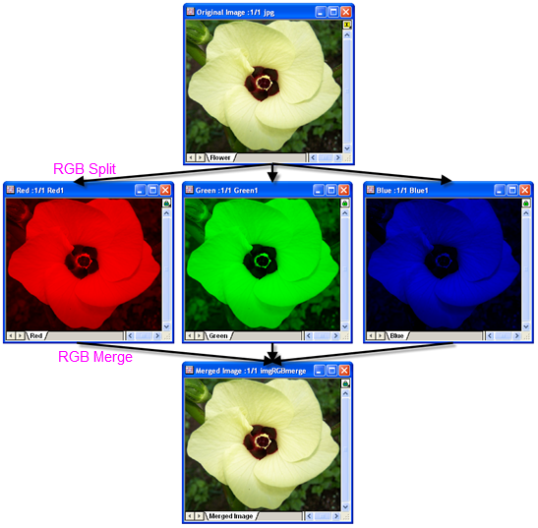

We can now see that each pixel of an image is combination of three colors value which are red, green and blue color and the values are 8 bits (The range is 0-255).

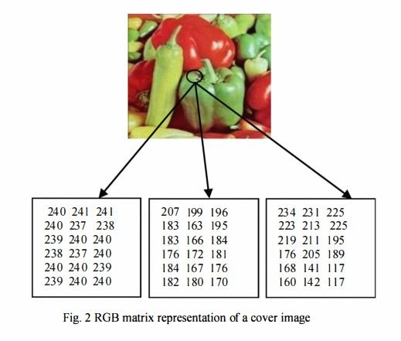These values are represented as binary code (the computer language). In this binary code the leftmost bit is the most significant bit and the rightmost bit is the less significant bit. **Here we hide messages inside an image by replacing Least significant bit of image with the bits of message to be hidden and it is called 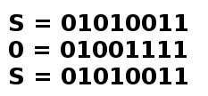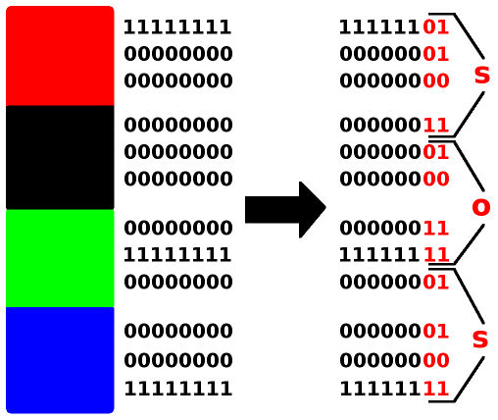LSB METHOD.**

**Process of hiding an image inside another**

In this part we will discuss the steganography process between two pictures by representation of python code processes.